

**<Game Title>**

***An iOS Fitness RPG***

A Major Qualifying Project Report

submitted to the faculty of

Worcester Polytechnic Institute

in partial fulfillment of the requirements of the

Degree of Bachelor of Science

on October X, 20XX.

Submitted By:

____________________

Maxwell Perlman

____________________

Stefan Alexander

Advised By:

____________________

Professor Robert Lindeman

**Abstract**

For design and development of

<GAME TITLE HERE>

By

Maxwell Perlman and Stefan Alexander

This report is focus on.

This document discusses…

The game …

Through the use of the iPhone’s new M7 chip, in conjunction with iBeacon Bluetooth devices, we created an iPhone role-playing game that is meant to encourage players to have a healthier lifestyle. The player engages in a real world role-playing game experience where the way they exercise in reality impacts their digital avatar’s traits and abilities. The goal of this game is to encourage exercise through in-game benefits to the player’s character, with the hope of eventually changing the player’s lifestyle to incorporate more exercise.

**Acknowledgements**

Our project could not have been completed without assistance from the following Ritsumeikan University students and faculty, as well as all of the Ritsumeikan University play testers as well as all Media Experience Design Lab members:

* Professor Noma:
* Wakao Asuka:
* Kohno Hitomi: Beta Art

Additionally, we would like the thank Alex Clemens, Professors Lindeman and Moriarty

* Alex: Art
* Professors Lindeman and Moriarty: For their guidance

**Table of Contents**

1. Introduction
   1. Project Proposal and Purpose
   2. Gameplay Inspirations and Related Works
      1. RPG & JRPG Genres
      2. Ingress
      3. Dungeons and Dragons
      4. Find Mii
   3. Team Members and Responsibilities
2. Development
   1. Getting Started
   2. Xcode and iOS
      1. Swift vs. Objective-C
      2. Frameworks
         1. MapKit
         2. SpriteKit
         3. Multipeer Connectivity Framework
         4. CoreLocation
         5. CoreMotion
            1. M7 chip
         6. Darwin
         7. Accounts
      3. UIPickerViewDelegates
      4. Local Push Notifications
      5. NSUserDefaults
      6. PrepareForSegue
      7. NSTimer
      8. AppDelegate
      9. Dispatch_get_global_queue
   3. IBeacon
   4. Server and Database
   5. GitHub
3. Design
   1. Initial Decisions
      1. Understanding Our Audience
      2. Japanese Audience
      3. Violent vs. non-violent gameplay
      4. Multiple characters per player?
      5. Managing Expectations
      6. Original design intention and simplification
   2. Experiential Goals
   3. Art and Style Guide
   4. Combat System
      1. Excel / Google Docs: Spreadsheet
      2. References
      3. Entities
         1. Traits
         2. Player
            1. Character Growth

Through gameplay

Through exercise

* + - * 1. Player Attacks and Abilities

Requirements to learn attack

The math

* + - 1. Enemies
         1. Possible growth rates

Trait values vs. level

* + - * 1. Types

Picture of enemy

Growth rate of each trait value and resulting tables

Original Art Request

Design based on …

List of attacks

Math behind attack

Power of attacks vs. level

* + 1. Testing Procedure
       1. Computer automated testing
       2. Player based testing
  1. Rank System
  2. Future design areas and expansion possibilities
     1. Expanding audience
        1. International audience
        2. Non-account based login
        3. Alternate Device Support
           1. Android Support
           2. Non-M7 iOS device support
     2. Implementation of additional iBeacon devices
     3. Deeper combat system

1. Gameplay Guide
   1. First gameplay experience
   2. Subsequent gameplay experiences
2. Timeline
   1. Initial timeline
   2. Actual timeline
   3. Unimplemented features and explanation
3. Produced Materials
   1. Code
   2. Art Assets
   3. Gameplay Math Tables
4. Reference Materials

**List of Figures**

**List of Tables**

**Introduction**

**Project Proposal and Purpose:**

The original idea for the project came from our (Maxwell Perlman’s and Stefan Alexander’s) love of traditional role-playing games and Japanese role-playing games. Our original proposal was the following:

*Through the use of phone based GPS technology, players can form a party of people in order to complete quests and defeat monsters. Players will be able to see the characters of those located close to them and are able to group together in order to become stronger. Providing a method for players to experience a Dungeons and Dragons level of fantasy immersion, possibly including a way for players to design adventures for their friends, while connecting it to real-world locations and objects could lead to a very deep immersive fantasy experience.*

Professor Noma then proposed that we adapt our idea to be a game that encourages the players to exercise and become healthier. Additionally, Professor Noma then stated that he wanted us to use iBeacon Bluetooth devices in our project in some respect.

After discussing these ideas form Professor Noma, we adapted our ideas in order to include these proposals. These proposals had a very large impact on the final vision we had for the game. First, we realized that we would have to design a way for the exercise habits of players to impact their avatar. Secondly, we had determined exactly how we would design multiplayer gameplay, thanks to the iBeacon devices. Once we had determined these things, we began the development of our game.

The following section will cover the entire development of the game from start to finish. Simultaneously with development, design decisions, both high and low level, were being made.

**Gameplay Inspirations and Related Works**

**RPG & JRPG Genres**

Heavily inspired by the role-playing and Japanese role playing game genres, we quickly realized that we wanted the game to feature major elements from these genres most importantly a turn based combat system as well as elements of exploration. The following games in this genre were major inspirations for the games design: The Final Fantasy series, Bravely Default, etc.

**Ingress**

Ingress is an augmented reality multiplayer game. Players are divided into two teams (blue and green) and these teams compete to take over the world. Players use their cell phones in order to set up virtual towers and capture areas of the earth. Players try to increase the power and range of their own faction’s control of are while waging war on the opposing faction. Ingress was a major inspiration to us because of its excellent mapping of real world locations to meaningful in-game locations. However, there were many aspects of Ingress that we felt were poorly designed or did not encourage the behavior that should be adapted while engaging in a game that takes place in the real world. Our goal is to provide an experience with a similar use of real world locations while at the same time not allowing this type of behavior during gameplay, specifically playing the game while driving.

**Dungeons and Dragons**

Dungeons and Dragons is a tabletop role-playing game that is played by groups of four to eight people. Normally featuring very limited physical resources; typically a player has nothing but a set of dice and sheet of paper with their character’s information. Guided by a non-playing person, known as a dungeon master, players band together to travel through fantasy worlds and dungeons to fight monsters, discover treasure, and even engage in conversation with non-player characters. We found inspiration through Dungeons and Dragons due to high level of immersion, to those who enjoy it, its high level of cooperative play, extremely deep and dynamic character creation mechanisms, and dynamic difficulty (set forth by both the game and the dungeon master). One of the major downsides to a game such as Dungeons and Dragons, which our game hopes to avoid, is the sedentariness of the players of the game. Typical a session of Dungeons and Dragons lasts between two and six hours, almost all of which consist of the players sitting down. Although our game will not provide the deep storytelling experience that Dungeons and Dragons does, we believe that due to the requirement of exercise for the progression of gameplay, our game will be able to achieve a high level of immersion.

**Find Mii**

Find Mii is a game built into the Nintendo 3DS handheld system. By leaving their system’s network on and keeping the system in sleep mode, a player carrying their system around with them during their day-to-day activities can collect other players. They can then use these players in order to defeat monsters and collect treasure, which can be seen by other players. We found Fine Mii to be a great inspiration it’s both its multiplayer gameplay mechanics as well as its simplicity. The only factor of Find Mii that we wish to avoid in our game is that the game does not actively encourage the player actually going out into the real world to play the game; players typically only play the game at the end of the day after having collected people.

**Team Members and Responsibilities**

Maxwell Perlman:

Stefan Alexander:

**Development**

**Design**

**Initial Design Decisions**

**Understanding Our Audience**

The first thing we had to define before we began the design and development processes was for what audience we are developing our game. Who would be downloading our game: young children, teenagers, college students, adults, or the elderly? Why are the players playing it: a desire for a deep gameplay experience, an enjoyment for augmented reality games, encouragement to begin exercising and walking more? We quickly realized that our target audience is young adults and adults who are looking for something to entertain them while they exercise. Some are more interested in the gameplay while others are looking for a gamified version of a pedometer. Understanding this, along with our game being targeted, initially, towards Japan and eventually the US, was the first major step in beginning the design and development process.

**Japanese Audience**

One of the first real decisions made was to develop this game for iOS. In recent history, iPhone games have become exceedingly popular, especially amongst people in our target audience, teenagers to people in their mid forties to fifties. That, combined with the omnipresence of iPhones on a national scale was more than enough to inform our decision and push towards developing for iOS.

We then took a look at both the American and Japanese app stores to gain an understanding of the popular applications as well as the degree of the presence of games in both cultures. We found that in the Japanese app store twenty-nine of the top thirty apps were classified as games. And in terms of the American market, we found that twenty-two of the top thirty apps were games. Combining this information with information gained from this report (<http://blog.appannie.com/japan-spotlight-revenue-inflection-point/>) in conjunction with the information we gathered, showing that of the top ten games in the Japanese app store, seven of them were role-playing games, helped to confirm that we were indeed creating a game for the correct audience.

Soon after deciding to develop for iOS we encountered an issue: How do we plan to store a player’s data? Do we make the data transferable to other devices or do we restrict it to a single device and not allow a person with multiple devices to use both for the game? We decided that players should be able to play the game on as many devices as possible, however this means that we need to store all of a players data on either Apple’s server or our own.

Our first instinct was to use the Apple provided service called Game Center to store our games data and maintain all multiplayer gameplay. However, due to the limited access to Apple services that we have as students, we were unable to access this service. We were then forced to brainstorm other solutions to this problem. In the end we wound up with two possibilities. We had decided between storing an email address for each player as well as a password, forcing them to login each time they want to play the game or using a different native iOS service called accounts. Any i-device is capable of storing account information with the following social media services: Twitter, Facebook, Sina Weibo, and Tencent Weibo. Due to the ubiquity of social media in Japan and America, namely Twitter and Facebook respectively, we decided that we would use this accounts framework to store our players data on our server. One of the benefits of this is the ability for the player to login using different i-devices with the same account.

**Violent vs. Non-Violent Gameplay**

Once having decided on the genre of our game, we had another important decision to make: was violent, combat based, gameplay acceptable for the audience we were to design the game for? To decide this, we looked to the most popular role-playing games in the Japanese app store. Of the 7 role-playing games in the top ten apps in Japan, five of them featured combat-based gameplay, sometimes abstracted to appear as card game or pinball, while only two did not. Although this is a small sample, we decided to follow the trend and determined that combat-based gameplay was acceptable, especially in light of the fact that our target audience is not young children.

**Multiple Characters Per Player**

Another important decision that had to be made about the gameplay was whether or not a player was allowed to have multiple characters. Due to the nature of how we are storing player information, based on social media accounts, we decided that we would not provide an inherent way for a player to create a “second” character, however if a player is so inclined, they are able to use a different social media account associated with their device to do so. We found this method to be most effective for gameplay, seeing that it is highly unlikely that a player will want to create a new character before their original character has reached a level that the player considers complete; allowing a player the opportunity to create a new character, but not highlighting it to players, most of whom have no interest in a second character.

**Managing Expectations**

Designing and developing a game in the role-playing or Japanese role-playing game genres comes with a lot of baggage. Players have many expected tropes and commonalities amongst these types of games. Consisting of complex combat systems, thousands of items, hundreds of enemies, complicated skill trees, and intricately designed worlds and story; role-playing games are amongst the most complex games due the shear magnitude of content these games typically feature. However, due to the audience we are targeting, many of these tropes are stand only to hinder our design. We had to acknowledge the tropes and evaluate which served to benefit our design and which tropes served to only make our design needlessly complex and lose our games identity if we conformed to them.

**Original Design Intention and Simplification**

This section serves to explain the evolution of our design; from an overly complex cliché filled design to a simplified one that keeps in mind the stereotypes associated with the genre but offers a new perspective on them. Our design began with an attempt to offer a deep role-playing experience and evolved into a far less complex one with a focus on exercise, which is what caused many design changes to take place.

**Design v1.0**

Our initial design proposal, completely ignoring all technical elements, can be broken down into the following systems:

* Class System: When a player first created their character, they would select from a number of different classes. This selection would have determined both the way their character’s traits evolve and the abilities, both in and outside of combat. Additionally, a character’s class would determine the type of weapons and equipment the character could use.
* Leveling System: As a player played the game, encountering and defeating monsters, their character would grow. Additionally, a character would be able to grow based on their exercise habits.
* Ability System: Consisting of both combat and non-combat based abilities, a character’s class would have determined their abilities. New abilities would be unlocked as the player levels up.
* Trait System: Each player’s character would begin the game with a preset value for each of his or her characters traits. As the character would level up would be given a set number of points to assign to each of their traits. This would have provided the player with a large amount of control of exactly how their character fights.
* Rank System: As a way to encourage competition between players, there would have been a ranking system, keeping track of which player had taken the most steps total as well as their average steps per day. Players would have been able to receive special items to show off to other players if they achieved a specific rank, for example: a special equipment for walking a specific number of steps every day for a week.
* Equipment System: Players would be able to equip their character with numerous different types of equipment (such as armor, head-gear, a weapon, an accessory, etc.). This equipment would be able to grant the player trait value boosts as well as abilities. Additionally, some equipment would have been class dependent, where some classes can use or cannot use certain equipment.
* Combat System: Player would encounter randomly generated enemies based on their character’s level. Player would engage in turn based combat with the enemy until one of their health values reaches zero. If the player lost the fight, they would lose a small amount of their current level progress and f they won, they would gain a small towards their current level progression.
* iBeacon Locations: Through GPS positions, players would have been able to meet up at iBeacon locations, stored on our server and marked accordingly on the main map. At these locations, provided enough players are present, the players would have either discovered a special boss enemy or would have each received a special item.

**Simplification**

Needless to say, this initial design was overly complicated, did not meet our new design goal, was too ambitions (especially due to our team’s lack of an assigned artist), and definitely not feasible to be done in 3 months by a team of 2 people. It is from here that the simplification process began.

The first major simplification to our proposal was the complete elimination of the class system. Although usually a cornerstone of role-playing games, the class system presented a challenge to create content that could not be met within the deadline. Not only would there have had to be a huge amount of content created, balancing the combat system to support this class system would have taken far too long. Instead, we designed a simplified character evolution system that is dependent only upon the character’s trait values. This has a large impact on both the trait, ability, and equipment systems.

After eliminating the class system, a few adjustments had to be made to the trait system. Originally, a characters base trait values were dependent upon the class they had chosen; however with the elimination of the class system the way the initial values were determined had to updated. We decided that when a player creates their character for the first time, they are given a set number of points. They can assign these points as they please and are informed of the impact of each of the traits on gameplay.

Soon after understanding the amount of content that would have had to be created for the equipment system, we realized that there was absolutely no way that we could support it; leading to the equipment system being cut. The reasoning behind this was that there was no way to test if it actually enhanced gameplay in a significant way without fully implementing it, which we were nervous to undertake.

After removing the class system, the ability system needed to be updated. We decided that in order to show a character growing, without a preset list of skills they would learn based on their class, that as a player put points into their trait values when leveling up, they would learn specific abilities. The other change to the ability system was the removal of non-combat abilities. We decided that these abilities were unnecessary and actually went against the vision we had for the game. We did not want to create a game where the player is constantly checking their phone for updates on their character’s status; the game is about exercising. The players should have to use their phone as little as possible, and non-combat abilities that are used on the map while the player walks around in the real world violates that vision.

As we began development, we moved forward with this design outline in mind.

**Experiential Goals**

Our design began with the following experiential goals. Provide a deep role-playing experience, similar in depth to that of Dungeons and Dragons. Through greater immersion, achieved through incorporating real-world locations gameplay, the experience had by the players would encourage players to go out into the real world in large groups and play games, rather than staying indoors for an extended period of time.

However, soon after beginning, the experiential goals of the project changed. The game we were creating became more fitness based and our experiential goals changed to reflect that. The main goal of the game we were creating became to encourage exercise through fitness-based gameplay. Our second goal, a more long-term one, became to inspire the player to change their attitude towards exercise to the point that even if they stop playing the game, they will want to incorporate more exercise into their daily life. Although providing a deep gameplay experience was no long the main goal of the project, we still tried to provide as deep a gameplay experience, done through the combat system, as possible while still maintaining our new main goal.

**Art and Style Guide**

Our original artistic vision was to create a game that visually looked like the game **Road Not Taken**. Each enemies original art request description is available below in the section titles Enemies in the Combat System. The following are sample images from the game **Road Not Taken** that we showed to our artist to serve as a style guide.

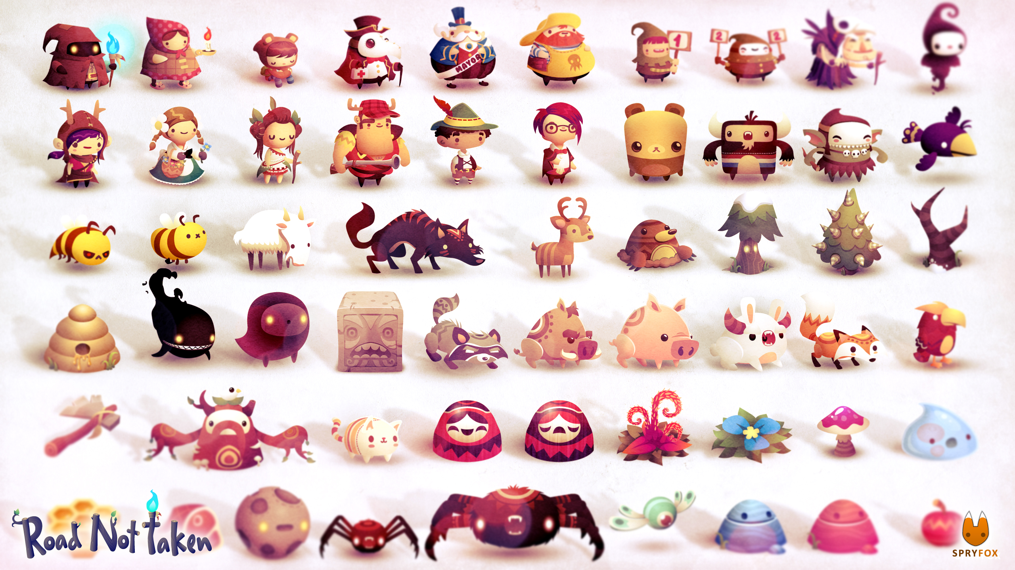

<http://image.noelshack.com/fichiers/2014/26/1403711429-1.jpg>

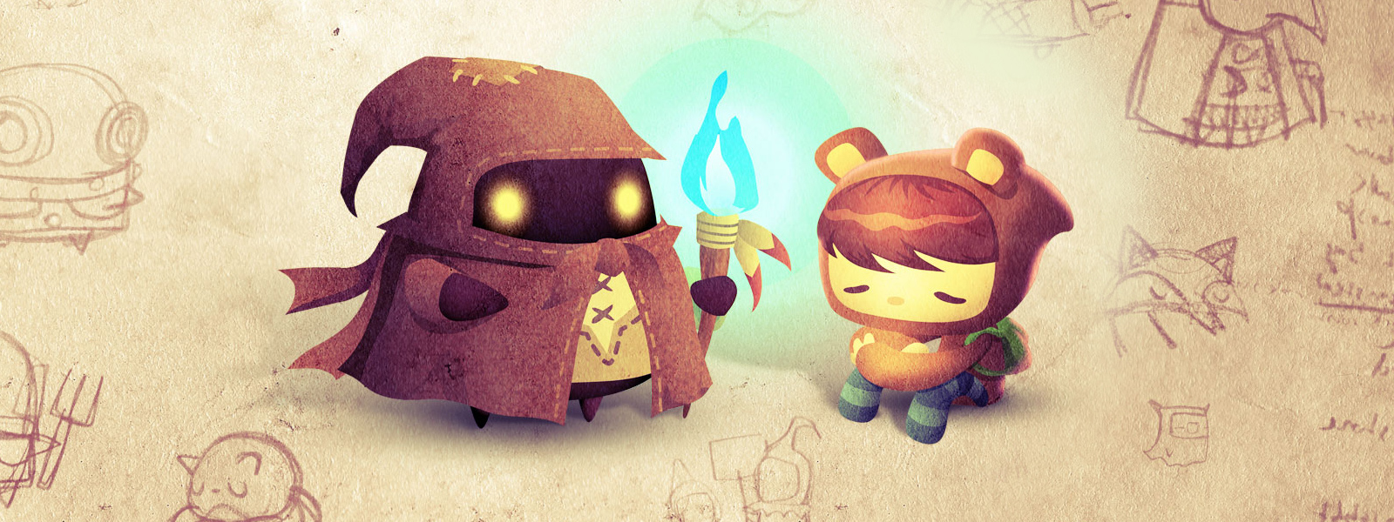

<http://oyster.ignimgs.com/wordpress/stg.ign.com/2014/08/RNT_073014_1600.jpg>

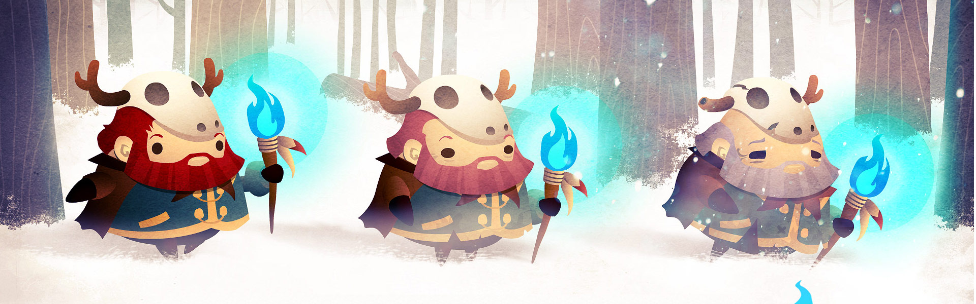

<http://blog.eu.playstation.com/files/2014/04/13577570084_a070632bd7_o.jpg>

**Combat System**

The cornerstone our projects gameplay is the combat system. We wanted to create a combat system with enough depth that a person could study and learn exactly how it works, similar to combat systems in traditional RPG’s such as Final Fantasy; however, we did not want to create a system so complex that we could not balance it within our limited timeframe. This section will completely explain how the combat system works.

**Excel / Google Drive: Spreadsheet**

**References**

**Entities**

To begin, both the player’s character and enemies fall under what we call entities. Entities are made of up the four essential traits, which determine the outcomes of the actions they take.

**Traits**

Both the player’s character and enemies consist of the following traits:

* Level: A players level is used to indicate their characters progression through the game while an enemies level is used in its trait value (health, strength, magic, and speed) calculations.
* Health: If at any point an entity’s health value becomes zero, that entity has lost the fight they are in. If it was an enemy whose health value fell to zero, the player won the fight and receives experience towards growing their character. If it was the player whose health value fell to zero, the play lost the fight. The consequence of losing a fight is that the player’s experience towards growing in level (as well as its trait values, explained below) will be reduced.
* Strength: Used in determining the power of physical attacks.
* Magic: Used in determining the power of magic attacks.
* Speed: Used in determining the order of entities in combat. It is also used for determining the outcomes of some physical attacks. This specific trait will be explained below, separately from the other traits as it far more complicated in its application.
* Current Health, Strength, Magic and Speed: These are used during combat so that if the entity is affected by an ability that lowers a trait’s value until the end of the fight, for example strength, the original value is maintained.

**Speed and Combat Order Calculation**

**Player**

In addition to traits mentioned above, the player also has one additional trait; points that may be assigned to the aforementioned traits. As the player’s character levels up, they will gain twenty points per level. These points are given to the player to assign to each trait (health, strength, magic, and speed) as they see fit.

**Character Growth**

As the gameplay takes place, there are two ways that the player’s character grows. The player’s character can grow through traditional gameplay by engaging in combat with an enemy and emerging victorious. The second way that a character grows is through the player exercising.

In order for a player’s character to go up a level, they must defeat a set number of enemies per level, specifically ten times the players level. After a player defeats the set number of enemies they will be given twenty points that they are free to assign to any of their traits.

As the player walks around in the real world, their exercise habits can help to grow their character. Each trait has a condition that must be met, and once that condition is met, the player’s character is given a set number of points to that trait.

* Health: EXPLAINATION HERE. For example: at ten thousand steps the player will gain one point to their health trait, at twenty thousand steps, the player will gain two points, etc.
* Strength: For every twenty-five enemies defeated, the player will gain three strength points.
* Magic: At the start of every day, a random hour is chosen, between eight am and midnight. If the player takes one thousand steps during the specified hour, they will gain one point towards their magic trait.
* Speed: Every instance of the player running, which is checked approximately every two seconds, they gain one thousandth of a point towards their strength.

**Player Attacks and Abilities**

The abilities a player can use during combat are broken down into three categories: Physical, Magic, and Utility. The following explains what the requirements are for the player to use a given ability as well as the outcome of using that move.

**Enemies**

In addition to the traits that all entities have, enemies have two additional traits. They are an enemy type and subtype. The enemies’ type determines the values of each of their traits (health, strength, magic, and speed). The enemies’ subtype determines the attacks the preform.

**Possible Growth Rates**

As production of the combat system began, we decided that the best way to understand the way the enemies evolve to match the player’s level, would be to use different but consistent growth rates for the enemies trait values.

There are eight mathematical formulas that are used in determining the values of an enemy’s trait, four of which are used at a time to determine values. The growth rate formulas are optimized for a maximum level of ten.

Firstly, there are five formulas used to determine the range of values used for the following three formulas calculations. An enemy’s trait value can be set to one of five different values: Very Low, Low, Medium, High, and Very High. Each of these functions passes three values on to the growth rate functions explained below. These three values are an offset (a value added to the end of each equation), a minimum value, and a maximum value.

* Very Low:
  + Offset = $level / 2$
  + Minimum = $level - 1$
  + Maximum = $level$

|  |  |  |  |
| --- | --- | --- | --- |
| Level | Offset | Minimum | Maximum |
| 1 | 0 | 0 | 1 |
| 2 | 1 | 1 | 2 |
| 3 | 1 | 2 | 3 |
| 4 | 2 | 3 | 4 |
| 5 | 2 | 4 | 5 |
| 6 | 3 | 5 | 6 |
| 7 | 3 | 6 | 7 |
| 8 | 4 | 7 | 8 |
| 9 | 4 | 8 | 9 |
| 10 | 5 | 9 | 10 |

* Low:
  + Offset = $level$
  + Minimum = $2 * level - 2$
  + Maximum = $2 * level$

|  |  |  |  |
| --- | --- | --- | --- |
| Level | Offset | Minimum | Maximum |
| 1 | 1 | 0 | 2 |
| 2 | 2 | 2 | 4 |
| 3 | 3 | 4 | 6 |
| 4 | 4 | 6 | 8 |
| 5 | 5 | 8 | 10 |
| 6 | 6 | 10 | 12 |
| 7 | 7 | 12 | 14 |
| 8 | 8 | 14 | 16 |
| 9 | 9 | 16 | 18 |
| 10 | 10 | 18 | 20 |

* Medium:
  + Offset = $2 * level$
  + Minimum = $3 * level - 3$
  + Maximum = $3 * level$

|  |  |  |  |
| --- | --- | --- | --- |
| Level | Offset | Minimum | Maximum |
| 1 | 2 | 0 | 3 |
| 2 | 4 | 3 | 6 |
| 3 | 6 | 6 | 9 |
| 4 | 8 | 9 | 12 |
| 5 | 10 | 12 | 15 |
| 6 | 12 | 15 | 18 |
| 7 | 14 | 18 | 21 |
| 8 | 16 | 21 | 24 |
| 9 | 18 | 24 | 27 |
| 10 | 20 | 27 | 30 |

* High:
  + Offset = $3 * level$
  + Minimum = $4 * level - 4$
  + Maximum = $4 * level$

|  |  |  |  |
| --- | --- | --- | --- |
| Level | Offset | Minimum | Maximum |
| 1 | 3 | 0 | 4 |
| 2 | 6 | 4 | 8 |
| 3 | 9 | 8 | 12 |
| 4 | 12 | 12 | 16 |
| 5 | 15 | 16 | 20 |
| 6 | 18 | 20 | 24 |
| 7 | 21 | 24 | 28 |
| 8 | 24 | 28 | 32 |
| 9 | 27 | 32 | 36 |
| 10 | 30 | 36 | 40 |

* Very High:
  + Offset = $4 * level$
  + Minimum = $5 * level - 5$
  + Maximum = $5 * level$

|  |  |  |  |
| --- | --- | --- | --- |
| Level | Offset | Minimum | Maximum |
| 1 | 4 | 0 | 5 |
| 2 | 8 | 5 | 10 |
| 3 | 12 | 10 | 15 |
| 4 | 16 | 15 | 20 |
| 5 | 20 | 20 | 25 |
| 6 | 24 | 25 | 30 |
| 7 | 28 | 30 | 35 |
| 8 | 32 | 35 | 40 |
| 9 | 36 | 40 | 45 |
| 10 | 40 | 45 | 50 |

Secondly, after the type of value to be used is determined, the value of the trait is assigned by using one of the following three growth functions: a logarithmic function, a linear function, and an exponential function. First, a random value between the minimum and maximum values (inclusive) is generated.

Based on these equations, we are able to determine the exact value an enemy’s trait will have. The following figure is a table of each possible value for each of the traits, showing its minimum and maximum values. In actual gameplay, the value will be within the range of the generated values.

Logarithmic:

* Formula: $10*\frac{\ln\left(level+1\right)}{\ln\left(10\right)}+\left(0.0414*level\right)+ offset+random-level$

|  |  |  |  |  |  |
| --- | --- | --- | --- | --- | --- |
| Level | Very Low | Low | Medium | High | Very High |
| 1 | 2:3 | 3:5 | 4:7 | 5:9 | 6:11 |
| 2 | 4:5 | 6:8 | 9:12 | 12:16 | 15:20 |
| 3 | 6:7 | 10:12 | 15:18 | 20:24 | 25:30 |
| 4 | 8:9 | 13:15 | 20:23 | 27:31 | 34:39 |
| 5 | 8:9 | 15:17 | 24:27 | 33:37 | 42:47 |
| 6 | 10:11 | 18:20 | 29:32 | 40:44 | 51:56 |
| 7 | 11:12 | 21:23 | 34:37 | 47:51 | 60:65 |
| 8 | 12:13 | 23:25 | 38:41 | 53:57 | 68:73 |
| 9 | 13:14 | 26:28 | 43:46 | 60:64 | 77:82 |
| 10 | 14:15 | 28:30 | 47:50 | 66:70 | 85:90 |

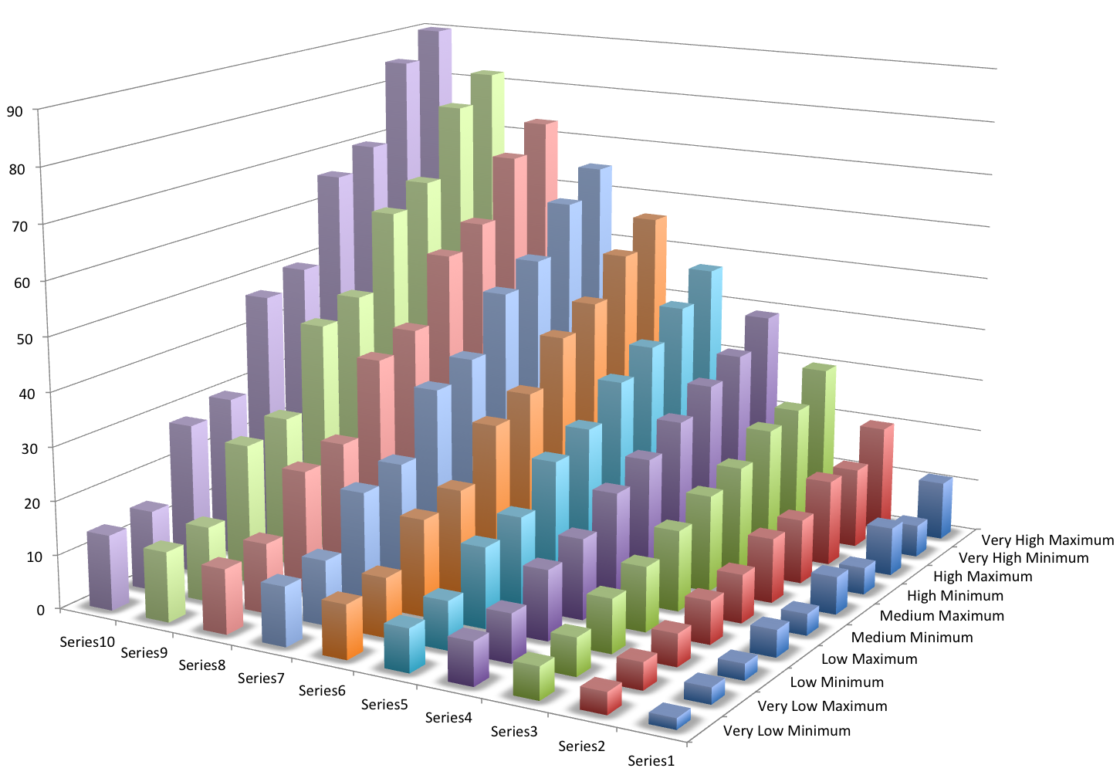

Linear:

* + Formula: $offset+random+level$

|  |  |  |  |  |  |
| --- | --- | --- | --- | --- | --- |
| Level | Very Low | Low | Medium | High | Very High |
| 1 | 1:2 | 2:4 | 3:6 | 4:8 | 5:10 |
| 2 | 4:5 | 6:8 | 9:12 | 12:16 | 15:20 |
| 3 | 6:7 | 10:12 | 15:18 | 20:24 | 25:30 |
| 4 | 9:10 | 14:16 | 21:24 | 28:32 | 35:40 |
| 5 | 11:12 | 18:20 | 27:30 | 36:40 | 45:50 |
| 6 | 14:15 | 22:24 | 33:36 | 44:48 | 55:60 |
| 7 | 16:17 | 26:28 | 39:42 | 52:56 | 65:70 |
| 8 | 19:20 | 30:32 | 45:48 | 60:64 | 75:80 |
| 9 | 21:22 | 34:36 | 51:54 | 62:72 | 85:90 |
| 10 | 24:25 | 38:40 | 57:60 | 76:80 | 95:100 |

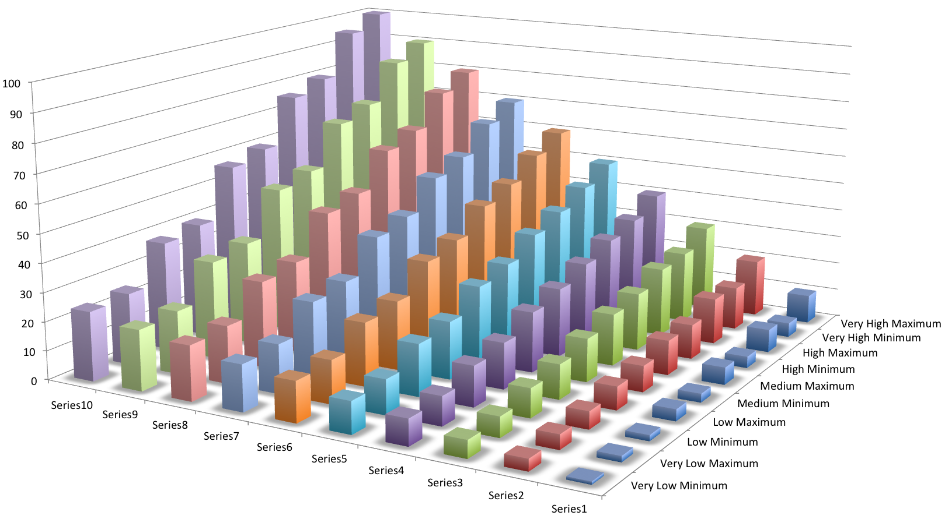

Exponential:

* Formula: $\frac{level^{2}}{4}+offset+random$

|  |  |  |  |  |  |
| --- | --- | --- | --- | --- | --- |
| Level | Very Low | Low | Medium | High | Very High |
| 1 | 0:1 | 1:3 | 2:5 | 3:7 | 4:9 |
| 2 | 3:4 | 5:7 | 8:11 | 11:15 | 14:19 |
| 3 | 5:6 | 9:11 | 14:17 | 19:23 | 24:29 |
| 4 | 9:10 | 14:16 | 21:24 | 28:32 | 35:40 |
| 5 | 12:13 | 19:21 | 28:31 | 37:41 | 46:51 |
| 6 | 17:18 | 25:27 | 36:39 | 47:51 | 58:63 |
| 7 | 21:22 | 31:33 | 44:47 | 57:61 | 70:75 |
| 8 | 27:28 | 38:40 | 53:56 | 68:72 | 83:88 |
| 9 | 32:33 | 45:47 | 62:65 | 79:83 | 96:101 |
| 10 | 39:40 | 53:55 | 72:75 | 91:95 | 110:115 |

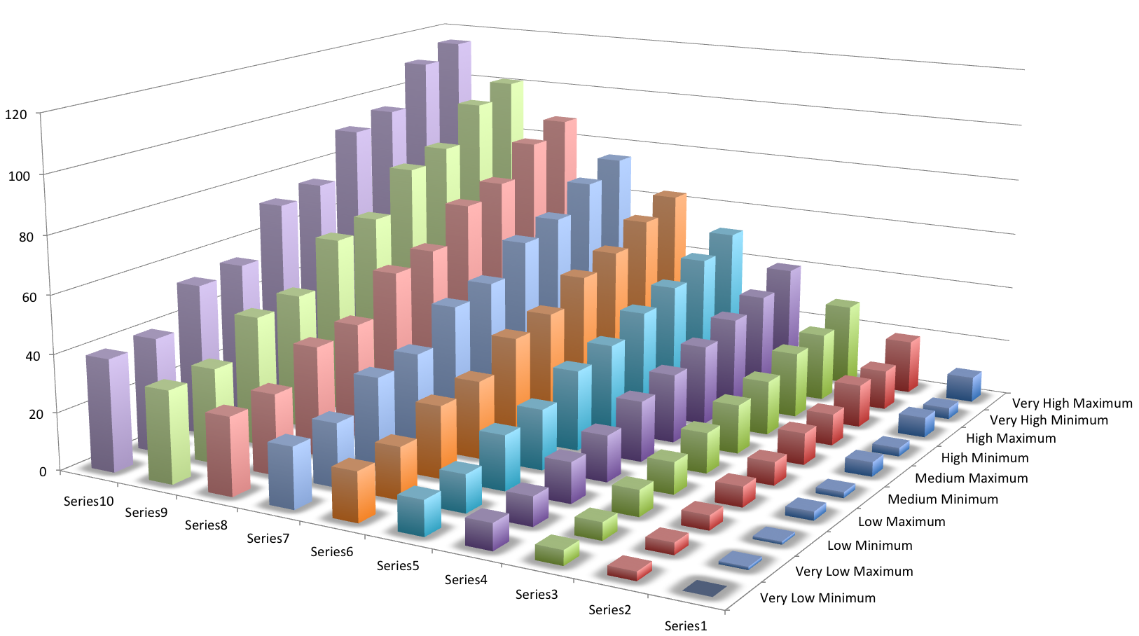

**Gameplay Guide**

**Timeline**

**Produced Materials**

**Reference Materials**